Name : Vivek Singh
RegNumber : 230905408
Roll Number: A50

Lab 2: PRELIMINARY SCANNING APPLICATIONS

Q1)Write a program that takes a file as input and replaces blank spaces and tabs by single space and writes the output to a
file.

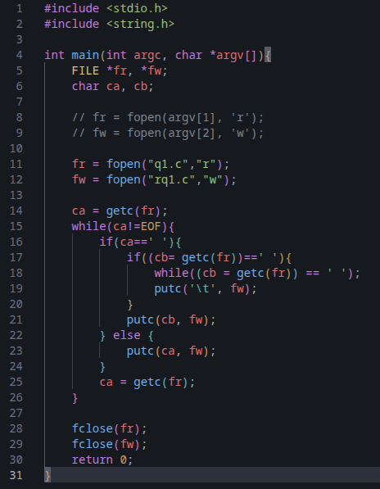
Code:

Output:
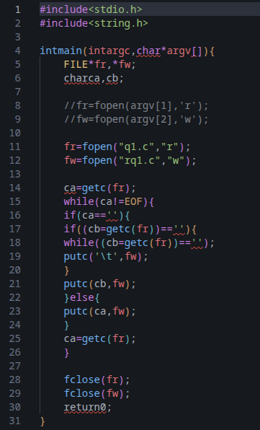

Q2) Write a program To discard preprocessor directives from the given input ‘C’ file.

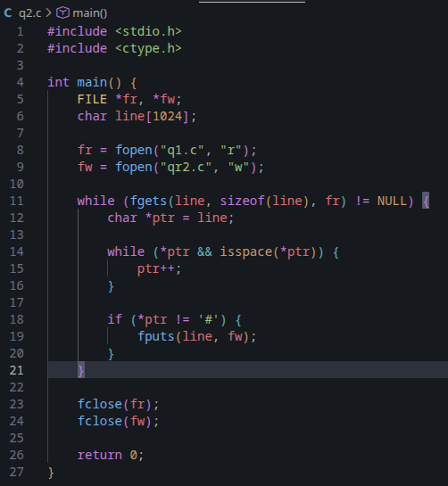

Code:

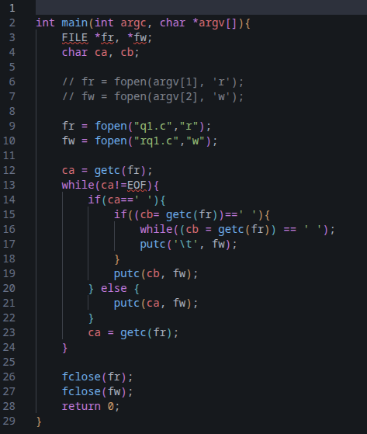
Output :

Q3) Write a program That takes C program as input, recognizes all the keywords and prints them in upper case.

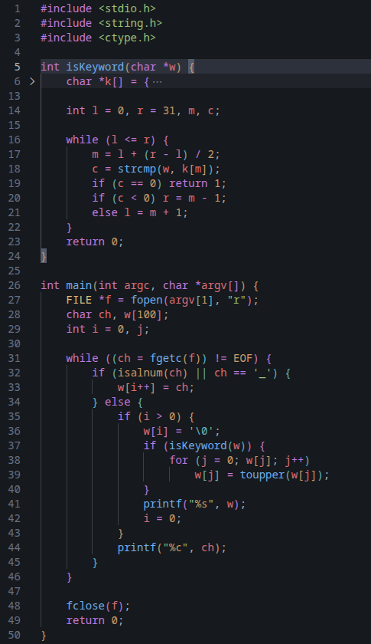
Code:

Output :
